Fresher’s Training – Final Test - .Net

|  |
| --- |
| **NOTES:**   1. Please read business story and all requirements carefully. 2. Mockups provided are just for reference, feel free to use your **creativity**. 3. Deliverables include **\*.zip** file with your source code and database scripts. Format <Name>_<EmployeeId>_FinalTest.zip 4. Also provide a “**How to setup**” guide to bring application to running condition. 5. Please go through the evaluation criteria provided at last.   **Duration: 60 hrs**  **Maximum Marks: 100** |

# Business Story

A campground owner wants to expand the business by launching a website.   
We have been hired to design a web-based platform giving tourists the ability for online booking and cancellation. Also, the owner should be given an admin page to add/remove camps and specify the rate.

# Requirements

The application being created should fulfill the following requirements. The validations are mentioned wherever relevant. Please refer mockups for better understanding.

1. Dashboard: This screen shows the camp listing
   1. Only camps available on the selected dates should be shown.
   2. Pagination should work.

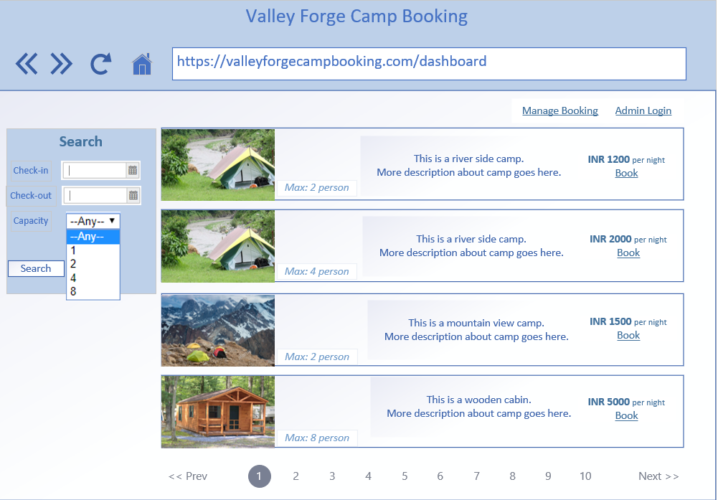

1. Search/Filter-by section
   1. Give option to select check-in and check-out date.
   2. Give option to choose “Capacity”. (Any, 1, 2, 4, 8 etc.)
   3. Defaults should be:
      1. Check-in date: Today’s date
      2. Check-out date: (Check-in date + 1 day)
      3. Capacity: Any
   4. Clicking “Search” button should refresh dashboard appropriately.
2. Booking screen
   1. Total amount being charged for the stay based on number of nights.
   2. Billing Address
   3. Cell Phone
   4. For simplicity assume
      1. One camp can be booked in a one booking.
      2. Payment is out of scope. It will be done at the time of check-in at the property.

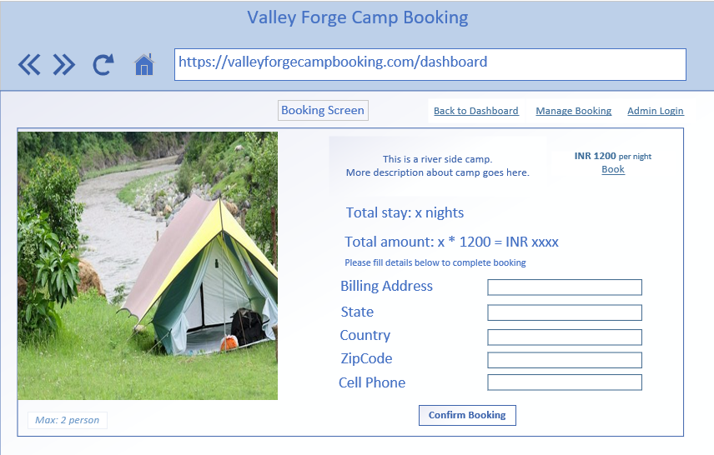

1. Confirmation screen
   1. Create a confirmation screen showing all relevant details.
   2. Generate unique 8-digit alpha-numeric code as “**Booking Reference Number**”
   3. After confirmation the camp should no longer be visible on dashboard for booked dates.
2. Manage booking
   1. Enter booking reference number to fetch booking
   2. Button to cancel
      1. Should only be allowed on future date bookings.
      2. Should make the camp visible again on the dashboard for cancelled dates.
3. (Admin only) Manage Camps
   1. “Admin Login” on dashboard screen will take to the Login screen.   
      (Note: You can assume admin to be identified based on “isAdmin” flag in database)  
      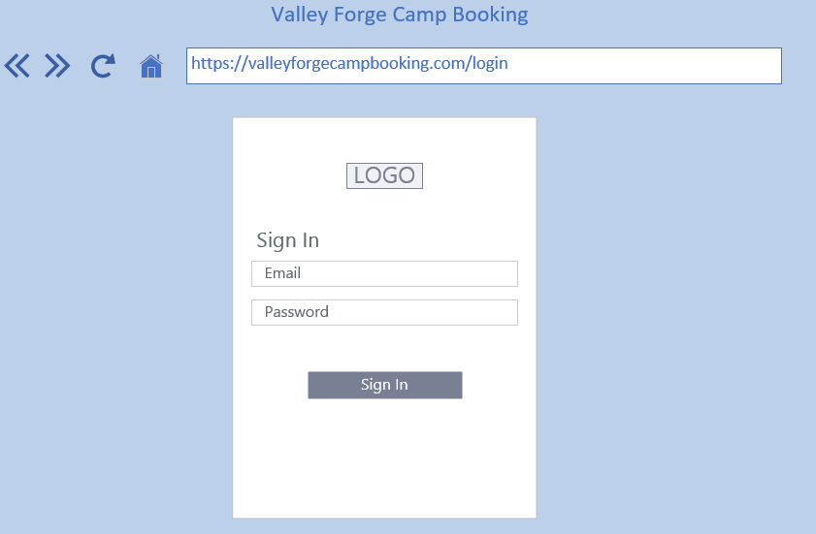
   2. After successful login the admin lands on dashboard but has extra button to “Manage camps”.
   3. Clicking on “Manage Camps” button takes to a screen with two tabs.
      1. Add new camp (mockup below)
      2. Manage existing camp (List all camps to with update and delete buttons)

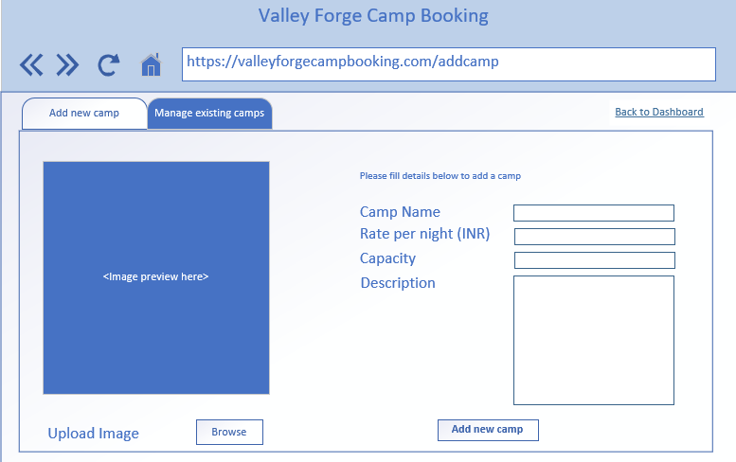

# Bonus Questions

1. Star-rating system in manage booking screen for bookings of past date. (Show the average star rating on dashboard)
2. Differential per night rate for weekdays and weekends (Fri/Sat/Sun).

# Sitemap

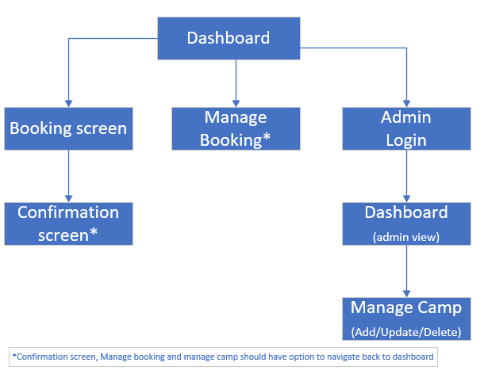

# Question 1

Create an end to end functional application using n-tier architecture to achieve the business story discussed above. To aid your thinking process and to set expectations in terms of output required find listed below the various components that go into making such an application

1. SQL database
   1. Should contain tables (if you want procedures – not mandatory) required for the business case
      1. Consider good design – Normalization, Constraints etc.
      2. Map complete information
2. Data Access Layer
   1. Should contain classes to help interact with the database.
   2. Use Entity Framework for database interaction.
   3. Feel free to use procedures (if you created them above) or use entities alone to complete DAC operations.
3. Business Layer
   1. Should contain classes to represent the business logic to cover all the requirements mentioned in Requirements section.

NOTE: Any common code – DTOs, constants etc., which can be used by any other layer can be made part of Shared Layer (optional).

1. Presentation Layer: Highlight use of Asp.Net MVC 6 And/Or .NET WebAPI.
2. UI presentation layer using Angular 2, HTML, CSS, JS.
   1. This should take care of UI validations.
   2. Make RESTful calls to MVC controller for data.

The following diagram shows a high-level structure and data flow for the application.

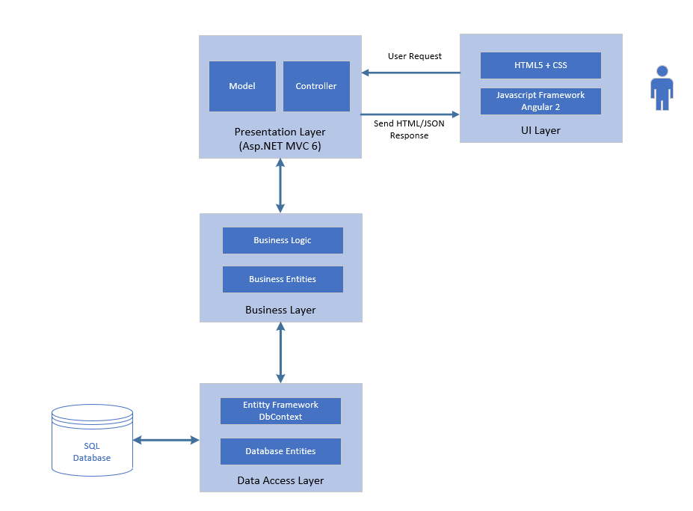

# Technology Stack

Following technologies should be used to create the application:

* UI Layer – HTML5, JS, CSS3, Angular
* Presentation Layer– Asp.Net MVC 6, Asp.Net WebAPI
* Business and Data Layer – .NET, Entity Framework, SQL Server

# Evaluation Criteria

The application will be evaluated against following criteria:

1. Basic application design and data structures usage.
2. Appropriate usage of OOP’s and SOLID principals.
3. Functional completeness.
4. **Make sure your application runs with sharing code on other’s machine and not just on your machine.**
5. Adhering to coding standards and guidelines.
6. Extra marks for attempting the Bonus Question.